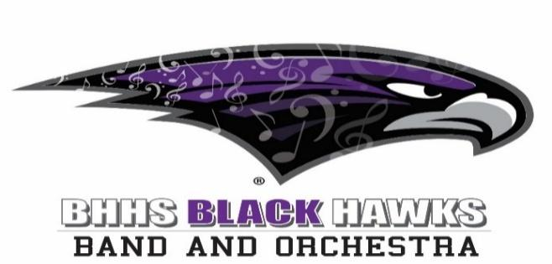

BBOB Meeting – August 11, 2025 - Minutes

1. | Welcome  See attached attendees below | Mike Morgan
2. | Annual Election of Board – August Election  BBOB Bylaws | BBOB  Jim to research how to add band camp director (Rebecca) to add  Board of Directors elected for a term of one (1) year as voted and approved:  Michael Morgan – President  James Baker – Vice President  Vanessa Gaunt – Treasurer/Acting Secretary for Banking  Joann Socha – Secretary  Jim Baker to research how to amend Charter to add Rebecca to Executive Board and Role  Approved – Band Camp coordinator into Executive Com. and approved Rebecca Fitzpatrick as Band Camp Coordinator to Executive Committee | Mike Morgan
3 | Approved – for financial spending – all executive group via group text to approve all expenditures only as 100% approval.  Put in minutes for Kendra Sosaphone in October – Morgan  Morgan Ask Libby to keep same website BUT revise what we have. Becky can update until we find a website person in interim. And new VENMO
4 | Directors Report – Mr Posner Present  Sunglasses for Band Students in and distributed  New Concession area and Ribbon Cutting for Wellness Center discussed – BBOB to donate popcorn and distribute for 9/12/25 event  Tap to Pay Discussed – Vanessa discussed getting away from VENMO and PAYPAL to another source for non-profits. This will save money in fees  Sign Up Genius for Game #1 Home game discussed. Mike to send to Steve for approval then distribute to existing band and orchestra parent list.  Discussion on Sprit wear to be delivered latter in September or October. More information due in latter meetings  Membership Committee – Jim for first meeting notice. Becky has freshmen list from camp for first August 11th meeting. Jim for email & cell for membership. Orchestra list parents? Becky to send list to Shawn.  Email Marching Band email list for dist.  Brennan need list of up-to-date Orchestra Parents  Link to New BBOB Calendar CALENDAR | BBOB
5 | 2025/6 School Year Events – Management and Chairs  See below as reviewed future events that will require BBOB support  Modify committee’s – Libby to modify  New committees now on BBOB Website | All
6 | Next Action Steps & Deadlines | All
7 | Meeting Adjourn | Mike Morgan
8 | Next Meeting September 8th @ 7pm (Usually the 1st Monday each month) | All

BBOB Committees

Membership - Jim
Website/social media - Becky interim, need committee head
Fundraising - need
Concessions - Steve Antone
Uniforms (concert, MB, shoes all one) - Thelma
Festivals – Jim
Jim to funnel below committees into above.

We do not need to address. (Incorporate into Above?)

See link for latest agreed committees

Concerts/Events List | BBOB

Discussed upcoming events for BBOB assistance

School Events for the 20205/6 School Year

8/20/25 6:30-8:00pm Need 10 volunteers for band uniform preparation for distribution at HS – Mike to send out Sign Up Genous for Thelma

8/25/25 Need 12 Band Uniform Distribution 4:00-6:15pm for seniors, juniors, sophomores and freshmen
Friday, August 22: 6p - 9p Saturday, August 23: 1p - 9p Sunday, August 24: 1p - 4p, concert at 3p Orchestra Retreat at HS
MB event: Walled Lake Preview Show - Sept 6th
Sep 8 2025 Pit Orchestra 3:00 PM - 6:00 PM - Orchestra Room
Sep 12 2025 BHHS Wellness Center Ribbon Cutting 5:30 PM - 7:30 PM - Main Gym A
Sep 22 2025 Pit Orchestra 3:00 PM - 6:00 PM - Orchestra Room
Sep 26 2025 Homecoming Football Game 6:00 PM - 10:00 PM
MB Event: Troy Invitational - Sept 27th CANCELLED
Sep 29 2025 Pit Orchestra 3:00 PM - 6:00 PM - Orchestra Room
Oct 6 2025 Pit Orchestra 3:00 PM - 6:00 PM - PA122 - Orchestra Room
10/13/25 3PM MSBOA Festival
Oct 20 2025 Pit Orchestra 3:00 PM - 6:00 PM - Orchestra Room
Oct 21 2025 Premier Concert 7:00 PM - 9:00 PM - Main Commons Cafeteria
Oct 27 2025 Pit Orchestra 3:00 PM - 6:00 PM - Orchestra Room
10/29/25 4PM Main Gym Band-O-Rama
Nov 3 2025 Pit Orchestra 3:00 PM - 6:00 PM- Orchestra Room
Nov 10 2025 Pit Orchestra 3:00 PM - 6:00 PM - Orchestra Room
Nov 11 2025 Pit Orchestra 3:00 PM - 6:00 PM - Orchestra Room
Nov 12 2025 Pit Orchestra 3:00 PM - 6:00 PM - Orchestra Room
Dec 8 2025 Collage Concert - Dress Rehearsal 3:00 PM - 6:00 PM
Dec 9 2025 Collage Concert - Music Department 7:00 PM - 10:00 PM - Main Commons
Dec 10 2025 Collage Concert - Music Department 7:00 PM - 10:00 PM - Main Commons
Feb 17 2026 Band/Orchestra Pre-Festival 6:30 PM - 9:30 PM
Mar 5 2026 MSBOA Festival 7:00 AM - 6:00 PM- Auxiliary Gym,
Mar 6 2026 MSBOA Festival 7:00 AM - 6:00 PM- Auxiliary Gym
Mar 24 2026 MSBOA Festival 7:00 AM - 6:00 PM - Auxiliary Gym,
Apr 11 2026 Spring Stroll 6:30 PM - 10:00 PM - Bloomfield Hills High School
Apr 23 2026 Traub Music Adjudication 8:00 AM - 2:30 PM - MC101A
Apr 24 2026 Traub Art Adjudication 8:00 AM - 2:30 PM - Media Center
Apr 27 2026 Traub Assembly and Reception 12:00 PM - 4:00 PM - Media Center
Apr 29 2026 Spring Band Concert 7:00 PM - 10:00 PM - Main Commons Cafeteria
May 13 2026 Spring Orchestra Concert 7:00 PM - 10:00 PM - Main Commons Cafeteria
May 18 2026 Senior Farewell Concert 7:00 PM - 9:30 PM - Main Commons Cafeteria
Jun 3 2026 Senior Concerto Concert 7:00 PM - 10:00 PM - Main Commons Cafeteria

2025 Bloomfield Hills Blackhawks Home Varsity Football Schedule

Home games. Sept 5,12,26 & Oct 17 – For Concession Volunteers

Attendees

